Real Shield in Cosmetic:

Lab testing and Efficiency

By Professor Luiz Bermudez: Oregon Professor and department Head of Biomedical Sciences, College of Veterinary Medicine at Oregon State University, Corvallis, Oregon.
Resistance of bacteria to conventional antibiotics has become an increasing concern in the microbial field. Research lead to the introduction of an unique formulation called Real Shield. This innovative compound, a blend of natural plant extracts, has shown remarkable capabilities. Real Shield comprises 12 pure inorganic compounds and plant extracts that are commonly referenced in the European Pharmacopoeia for bacterial processing. It not only controls bacterial growth without kill them and selecting for resistant organisms but also exhibits surprising effectiveness against various fungi and viruses. Real Shield also contain ingredients that act in the inflammatory process, by inhibiting the synthesis of selective mediators of inflammation.
Composition Real Shield
Plant extract | Arnica montana, Baptisia tinctorial, Bryonia dioica, Echinacea angustifolia, Phellandrium aquaticum, Pulsatilla, Sepia officinalis, and Thuja occidentalis
Inorganic compounds | Calcerea phosphorica, Causticum d’Hahnemann, Nitricum Acid, and Silacea

Each compound in the Real Shield formulation was meticulously selected based on its established anti-microbial and antifungal activities. For instance, Echinacea angustifolia stands out as the most potent species among the Echinaceas in terms of immune modulation. Recent research indicates that Echinacea offers both anti-inflammatory and anti-influenza benefits.
Similarly, Arnica montana is recognized for its anti-inflammatory and antimicrobial traits, primarily attributed to the presence of thymol and helenalin. Thymol can inhibit elastase release from activated neutrophils, which may reduce some inflammation-associated collateral damage. Additionally, it can thwart influenza A replication through the non-specific inhibition of protein synthesis. Helenalin acts against inflammation by inhibiting NF-κB signaling, specifically by alkylating the p65 subunit. While this anti-inflammatory action of helenalin is specific, general inhibition of NF-κB has been linked to the suppression of influenza-induced inflammation, owing to a reduction in caspase 3 activity and other pathways that are crucial for the nuclear export of viral ribonucleoprotein complexes.
Furthermore, extracts from Thuja occidentalis have been extensively researched either in isolation or in combination with other botanicals for their antimicrobial and immunomodulatory potentials. A recent review offers comprehensive insights into these findings.
In summary, Real Shield features a blend of ingredients renowned for their antimicrobial and immunomodulatory properties, and in the concentrations used place it as a potent contender for managing inflammation and infections. When prepared from its concentrated form, Real Shield can be diluted (typically at a proportion of 1:125-250) and dynamized in various solutions. These include:

• Purified water, typically used at a dilution of 1:125.
• A base oil combined with an added emulsifier.
• Essential oil, also with the addition of an emulsifier.
• Aloe Vera.3 different formulations have been tested:
Formulation | Percent
Water based (dilution 1:250). Called Paris Leaf Cream  - Real Shield  - Water | 0.8%  99.2%
Serum (dilution 1:125), Called Paris Leaf Serum  - Real Shield  - Water  - Aloe Vera  - Vitamin E  - Xanthan Gun  - Germaben | 0.8%  52%  42%  2%  2%  1%
Cream: (dilution 1:125). Called Paris Leaf Cream  - Real Shield  - Water  - Aloe Vera  - Oil base (Jojoba, Hemp, or…)  - Tea Tree Oil  - Vitamin E  - Emulsifier wax  - Germaben | 0.8%  30%  30%  26%  3%  2%  7%  1%

These formulations have been created and tested on virus, bacteria, and fungus.

Laboratory Test Results on the Formulations:

Paris Leaf Cream, Paris Leaf Serum, Paris Leaf Cream

Testing Method and results on virus:

Methodology

In our experiments, we assessed the antiviral efficacy of Paris Leaf Cream against the influenza A/PR/8/34 H1N1 strain in MDCK cells. We used a 1:20 dilution of the working stock of Paris Leaf Cream, which was already at a dilution of 1:125, in the virus growth medium. To gauge the impact of treatment timing relative to infection, we administered the treatment at various intervals: 1 hour before the infection and 1, 2, 4, or 12 hours post-infection. For control, cells were exposed to a 1:20 dilution of ddH2O with 0.4% ethanol in the virus growth medium. At both 24 and 48 hours post-infection, samples were drawn to determine the influenza titer using a hemagglutination assay.

Results
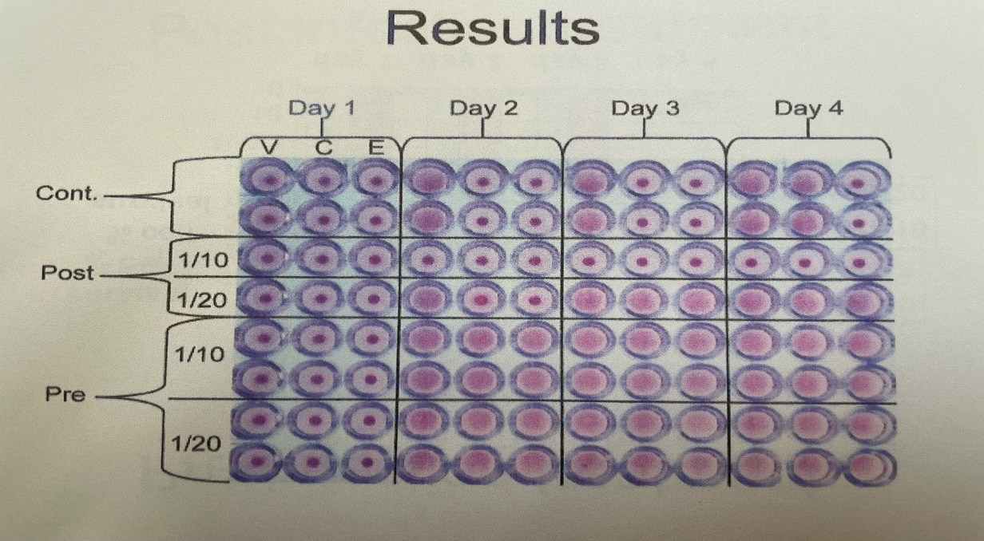
Both pre-treatment and post-treatment of MDCK cells markedly curtailed virus proliferation for a duration of at least 48 hours, especially when treatment commenced within 12 hours post-infection (as illustrated in Figure 1). The inhibition of influenza F was notably pronounced when the treatment was administered either prior to infection or within the first 4 hours post-infection..
Our findings suggest that a 1:250 dilution of Paris Leaf Cream effectively diminishes the growth of the influenza A/PR/8/34 H1N1 virus in cell culture, especially when the treatment is initiated within the initial 12 hours post-infection.
Experimental groups on H1N1: HA titer (48 hs)
Paris Leaf Cream control Paris Leaf Cream
No treatment 9,458 + 231 9,630 + 228
No dilution No growth No growth
1:100 dilution 8 8
1:1,000 dilution 16 16
1: 10,000 dilution 32 32
_____________________________________________________________________________

Implications: Real Shield is active against influenza A virus and can be used as topic preventive.

Testing Method and results on bacteria:

Methodology:
For this assay, an inoculum of 3 x 10^5 bacteria suspended in 10% LB growth medium in water was seeded onto a plastic surface, allowing biofilm formation over several days. On days 3 and 7, the supernatant was removed, the biofilm was disrupted, and the number of bacteria within the biofilm was determined by plating the suspension onto LB agar plates. Each experiment was conducted at least three times.

Results

Result in biofilm
a) Biofilm on a non-biologic surface.
a) One treatment. CFU at 3 and 7 days
Bacteria |  | Treatment |  | 3 days | 7 days
S. aureus |  | Saline |  | 1.4±0.4x10⁵ | 8.6±0.6x10⁵
 |  | Real Shield |  | 0 | 0
S. pseudintermedius |  | Saline |  | 1.6±0.6x10⁵ | 9.4±0.7x10⁵
 |  | Real Shield |  | 0 | 0
S. aureus methicillin |  | Saline |  | 1.9±0.4x10⁵ | 9.6±0.6x10⁵
 |  | Real Shield |  | 0 | 0
b) Three treatments. CFU at 4 days
Bacteria | Treatment |  | 1 day treatment |  |  | 2 days treatment |  | 3 days treatment
S. aureus | Saline |  | 4.7±0.6x10⁴ |  |  | 5.4±0.7x10⁴ |  | 7.3±0.4x10⁴
 | EK |  | 0 |  |  | 0 |  | 0
S. pseudintermedius | Saline |  | 5.1±0.3x10⁴ |  |  | 7.3±0.5x10⁴ |  | 8.8±0.5x10⁴
 | EK |  | 0 |  |  | 0 |  | 0
b) Biofilm on top of bovine mammary gland epithelial cells.
Biofilm established for 3 days
Bacteria | Treatment | Time 0 | After 2 days of treatment | After 4 days of treatment
S. aureus | Saline | 3.5±0.3x10⁵ | 4.7±0.4x10⁵ | 5.8±0.3x10⁵
 | Real Shield | 3.5±0.3x10⁵ | 1.0±0.2x10² | 0
S. pseudintermedius | Saline | 4.1±0.4x10⁵ | 4.9±0.6x10⁵ | 6.9±0.6x10⁵
 | Real Shield | 4.1±0.4x10⁵ | 1.2±0.4x10² | 0
c) Biofilm on bovine mammary gland epithelial cells. Comparison to Biofilm established for 3 days.
Bacteria | Treatment | Time 0 | After 2 days of treatment | After 4 days of treatment
S. aureus | Saline | 4.3±0.4x10⁵ | 4.9±0.4x10⁵ | 5.8±0.6x10⁵
 | Real Shield | 4.5±0.2x10⁵ | 2.0±0.2x10² | 0
 | Cephalothin | 1.2±0.4x10⁵ | 4.4±0.4x10⁵ | 3.5±0.6x10⁵

Anti-bacterial effect against a clinical isolate of Staphylococcus aureus (methicillin-resistant)
Experimental groups CFU/ml
Control Formulation
No treatment 2 x 10⁷ 3 x 10⁷
No dilution No growth No growth
1:10 dilution No growth No growth
1:100 dilution No growth No growth
1: 1,000 dilution 435 392
1:10,000 dilution 3,4 x 10³ 3,9 x 10³

Anti-bacterial effect. E. coli (clinical isolate)
Experimental group | CFU/ml
 | N-S | No N-S
No treatment | 3 x 10⁷ | 2.6 x 10⁷
Formulation | No growth | No growth
1:10 dilution | No growth | No growth
1:100 dilution | No growth | No growth
1:1000 dilution | 176 | 201
1:10,000 dilution | 6 x 10⁴ | 5 x 10⁴
1:100,000 dilution | 7 x 10⁵ | 6.5 x 10⁵
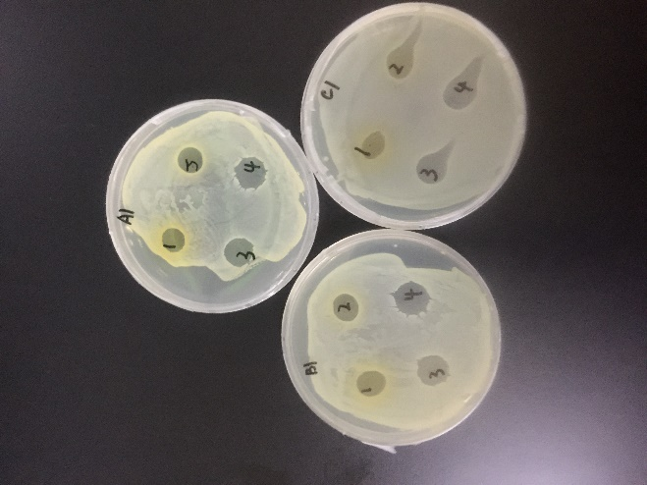
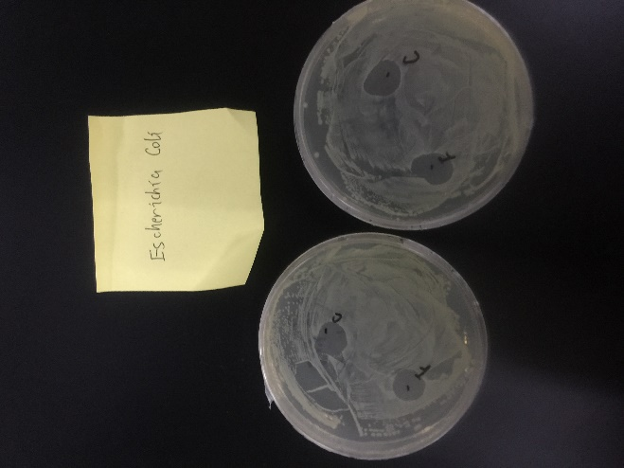

Test of Real Shield against staphylococcus methicillin resistant
 |  | growth
strain | source | no drug | vial concentration | 1:10
1937 | dog | growth | - | -
2309 | dog | growth | - | -
2275 | cat | growth | - | -
2227 | dog | growth | - | -
2168 | dog | growth | - | -
2392 | dog | growth | - | -
2394 | dog | growth | - | -
43300 | human | growth | - | -
(-) = no growth

Implications:
All formulations were tested against:
- Escherichia coli (associated with intestinal and urinary infections)
- Proteus mirabilis (associated with wound infections, various skin and soft-tissue infections, and atopic dermatitis)
- Staphylococcus aureus (commonly associated with skin infections, respiratory diseases, and food poisoning)
- Beta-hemolytic streptococcus
- Klebsiella pneumoniae
- 8 different strains (1937, 2309, 2275, 2227, 2168, 2392, 2394, and 43300) of Methicillin-Resistant Staphylococcus (S. aureus, S. intermedius, S. pseudointermedius). All of these strains were inhibited, even at a dilution of 1:10.
Collectively, these bacteria are implicated in a significant majority of skin diseases. Applying the formulation twice daily is expected to produce beneficial effects on the skin.

Testing Method and results on Candida albicans, a common commensal of the skin:

Methodology: As described above.

Results
Candida albicans
____________________________________________________________________________
Microbe None Water Base Serum Cream
______________________________________________________________________________
Candida albicans Growth No No No
______________________________________________________________________________

Implications
Candida albicans (associated with vaginal and skin yeast infections)

Test of Cream against S.aureus and Candida albicans
Method: Bacteria and Candida were plated on LB and Sabouraud agar respectively. Cream with a concentration of Real Shield of 0.8, 0.4 and 0.2 %.
 | S. aureus |  |  |  | Candida albicans
Time | 4h | 8h | 24h | 48h | 4h | 8h | 24h | 48h
None | 10⁵ | 10⁷ | 10⁹ | TMC | --- | --- | 10⁴ | 10⁵
0.2 | 10⁴ | 10⁵ | 10⁶ | 10⁷ | --- | --- | --- | 10²
0.4 | 10² | 10³ | 10⁴ | 10⁶ | --- | --- | --- | 10²
0.8 | --- | 10² | 10³ | 10⁵ | --- | --- | --- | <10²

This formulation offers 99% efficacy against skin pathogens, making it highly suitable for cosmetic applications. However, it should be noted that the formulation cannot be prepared at temperatures exceeding 30°C.

Discussion
Owing to its unique blend of inorganic compounds and plant extracts—each of which is recognized in the European Pharmacopoeia and known for its therapeutic properties—the in-vitro prophylactic action spectrum of Real Shield™ F, Paris Leaf Serum, and Paris Leaf Cream includes:
- Anti-viral properties.
- Anti-bacterial properties, which have driven our development of skin applications.
- Anti-fungal and anti-yeast properties.
- Anti-inflammatory properties.
With recommended usage twice daily, these products achieve an efficacy rate of 99% against skin pathogens, making them ideal for cosmetic applications. However, it's crucial to note that the formulation should neither be prepared nor stored at temperatures exceeding 30°C.

